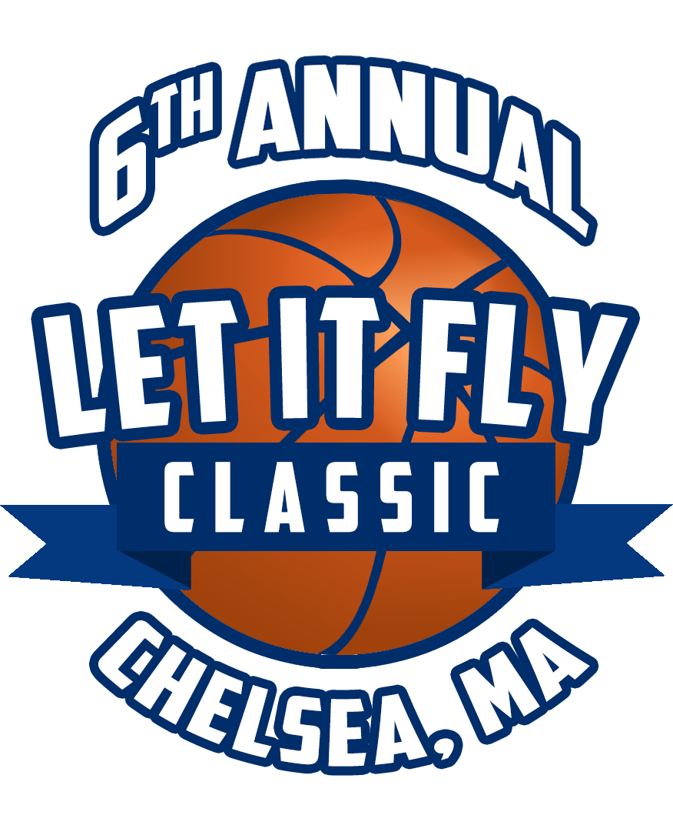

June 30, 2022

Hello,

On behalf of Let It Fly Classic in conjunction with Chelsea Black Community (CBC) we are hosting our Seventh Annual Let It Fly Classic Basketball Tournament. All proceeds will be donated toward scholarships for Chelsea High School and Chelsea Opportunity Academy, Class of 2023. The tournament will be held on August 13, 2022 at Chelsea High School, 299 Everett Ave, Chelsea, MA. Games and entertainment will begin at 10am-6pm.
We are Kyle Umemba and Cesar Castro, lifelong residents of Chelsea and graduates of Buckingham Browne and Nichols and Chelsea High School. Cesar and I have witnessed many positive changes within our city yet there continue to be setbacks that many youths of Chelsea experience.
We are asking for your support to ensure the tournament will be a success! We hope that you will be a part of providing an opportunity to promote educational growth for the young people of Chelsea, individuals that someday will be leaders of our great community.
This year, our goal is to match 2021 efforts by providing TEN scholarships again! Your donation will greatly assist in reaching this total.
Event will provide:
- Food and Drinks, Sports and Goodie Baskets, Raffles, Basketball Tournament
- Meet Local Officials, Local Businesses, Live Entertainment and DJ

With your donation, your business will be given the opportunity to receive exposure to 500-1000 new potential physical impressions and 5000 social media impressions.
Three main ways of impressions:
- Large banner of business card/logo will be visible at the entrance of the park and broadcasted throughout the tournament.
- Logo placed on flyers that will be advertised throughout the city of Chelsea.
- Business name mentioned Facebook, Twitter Feed of more than 5000 fans and followers.

Enclosed is a donation form for you to fill out to participate in this vital project. If you would like more information about Let It Fly Classic Basketball Tournament, please feel free to call Kyle Umemba at 617-821-6267 or email LetitflyClassic@gmail.com

Please submit the attached form before July 29, 2022
PAYMENT MUST BE RECEIVED BY AUGUST 5th IN ORDER TO HAVE YOUR LOGO PLACED ON TEAM JERSEY

Website Link: https://www.letitflyclassic.com
GoFundme Link: https://secure.actblue.com/donate/7thannualletitflyclassic

Sincerely,
Kyle Umemba & Cesar Castro
Let It Fly Basketball Classic Tournament

